First we observe the code of the bomb.c file：

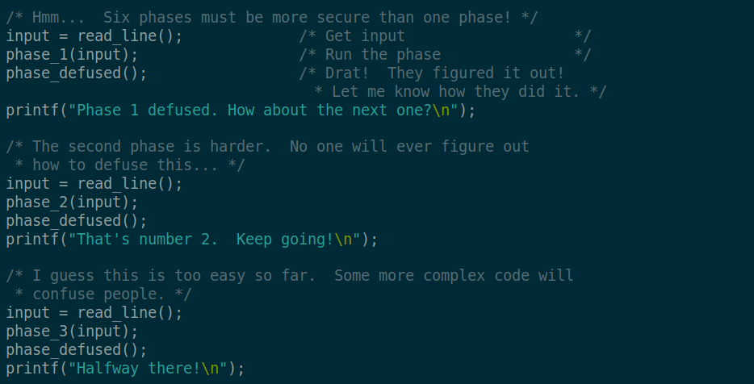

It can be clearly observed that the logic required to determine whether the input string is required to disarm the bomb exists in the phase_1, phase_2...phase_6 functions. We only need to figure out the internal logic of these functions, then we can know the string required to disarm each bomb.

Next, here will describe the process of disarming the 6 bombs:

1. phase_1:

First debug the ./bomb executable file through gdb:

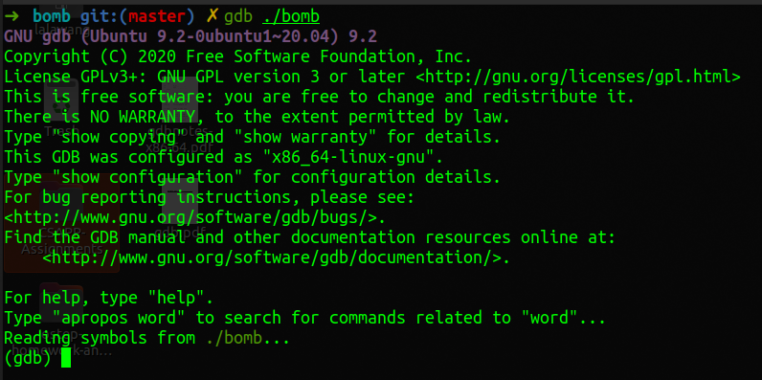

According to the logic described above, we set a breakpoint at the phase_1 function: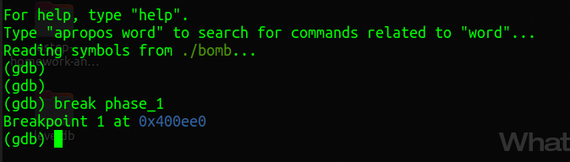

Then enter the **run** command to run:

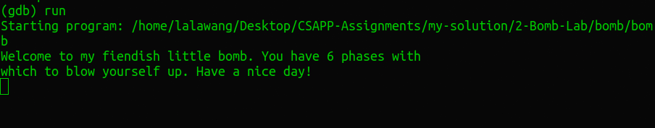

At this point, the program asks us for the first string to disarm the bomb. Here, enter “testString”, and then the program will stop at the breakpoint we hit: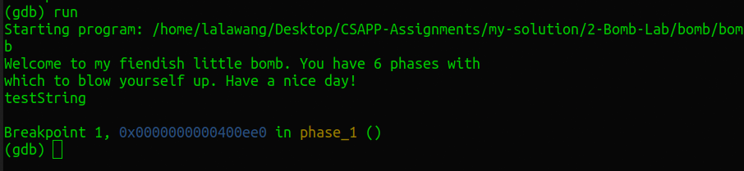

In order to figure out what is happening inside the phase_1 function, use the **disas** command to disassemble the function:

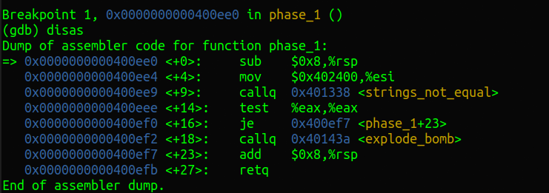

Observing the logic of the assembly code here, it is actually based on the running result of the function ***strings_not_equal*** to decide whether to call the explode_bomb function. If this function is called, we will fail this time, so we need to understand what the function ***strings_not_equal*** does. Also hit a breakpoint, and let the function go to this breakpoint at the same time:

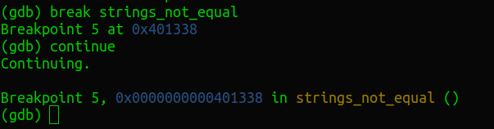

Once again, disassemble the ***strings_not_equal*** function:

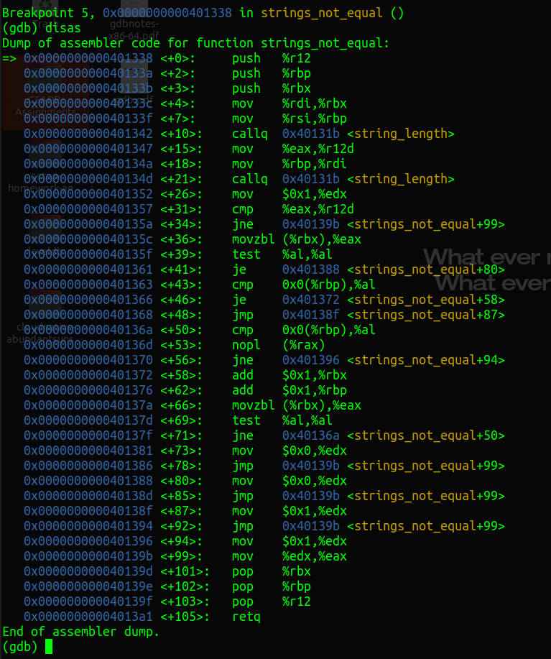

Pay attention to the code in the two places <+10><+21>. In fact, the ***string_length*** function is called twice to obtain the length of the input string and the target string, and the result is stored in the %r12d and %eax registers. Say that the lengths are not equal, then jump directly to <+99>, what it do is set the value of register %eax to 0x1, and looking back at the assembly code of the ***phase_1*** function, you can find that if the %eax register‘s value is not 0, the bomb will explode. Therefore, we can infer that calling the ***string_length*** function twice is to obtain the length of the input string and the target string. We only need to look at the parameters corresponding to the two function calls. It is the value stored in the corresponding address of the parameter register %rsi and %rdi:

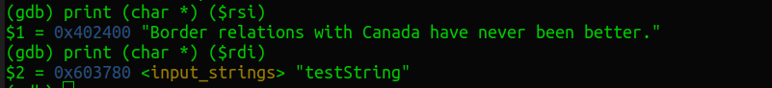

The %rdi register corresponds to the test string “testString” that we temporarily input before, which also verifies the previous conjecture, so the other is what is needed to disarm the bomb:

**Border relations with Canada have never been better.**